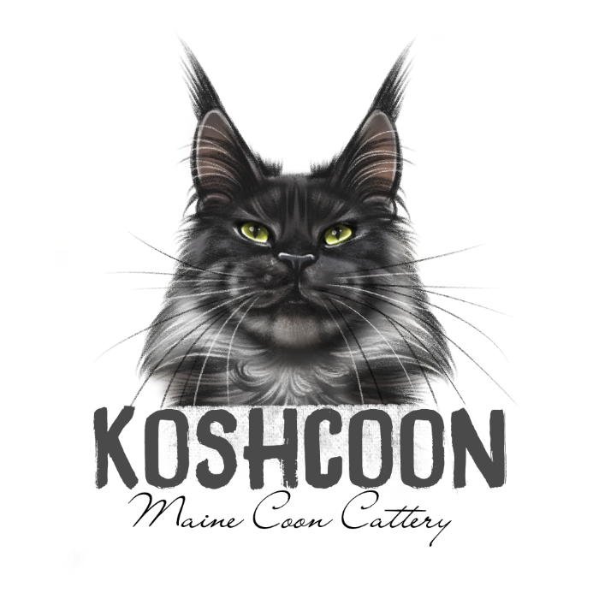
KOSHCOONS KITTEN APPLICATION

Thank you for taking the time to fill out our application. We take all applications into consideration and make it our top priority to find the best homes for our kittens. We require lots of information so that we are able to understand our prospective family better and get an idea of how our kitten will enrich in your home. This application lets us know you are serious about kitten adoption. Our kittens are available ONLY for pets and the number available for each pairing is dependent upon mother nature so be aware that some people may wait up to 1 year for a kitten!

- Name: ________________________________________________

- Address: _______________________________________________
City: ______________________ State: ________ Zip: ______

- Phone Number: _____________________________

- Email: ______________________________________

- Facebook account name: ___________________________

- Have you ever owned a Maine Coon in the past? _____________________

- Do you have other pets? __________ If yes, please list them:
___________________________________________________________
___________________________________________________________

- Are you pets allowed on couches or beds in your home? _________________________________________________________
_____________________________________________________________

- Will your cat have outside access of any kind? _____________________

- Have you ever had a cat declawed? __________________

- Do you have a color preference? __________________________

- Do you have a gender preference? _______________________

- If waiting for a kitten from a specific pair, please list the pair here: _____________________________________________________________________

- Do you willing to wait for a kitten if your color/gender preference isn’t available from the current litter? _______________________________

- Have you ever given away or taken back a pet for any reason? ___________
If yes, please explain: ________________________________________________________________________________________________________________________________________________________Do you agree to a $500 deposit to reserve a kitten if you are contacted to adopt a Koshcoons kitten? _______________ This deposit can be refunded under certain circumstances ONLY decided by Koshcoons.

- Do you have any questions for us? ____________________________________________________________________________________________________________________________________________________________________________________________________________________________________

- Tell us some details about you and your family. Your career, kids, and family life. ________________________________________________________________________________________________________________________________________________________________________________________________________________________________________________________________________________________________________________

- Please help us to better our breeding by telling us what attracted you to Koshcoons cats? ________________________________________________________________________________________________________________________________________________________

- How did you originally hear about Koshcoons? __________________________________________________________________________________________________________________________

- Do you agree that if you must surrender or give up your kitten or cat no matter how many years it has been since purchase that you will contact Koshcoons and allow us to purchase your kitten or cat back for a price of $500? ___________

~~~~~~~~~~~~~~~~~~~~~~~~~~~~~~~~~~~~~~~~~~~~~~~~~~~~~~~~~~~~~~~~

Thank you for your interest in our kittens! Please note that you will only be contacted after a litter is born if we think you would be a good fit for a kitten! Please remember that filling out an application does not guarantee you a kitten from Koshcoons and we reserve the right to refuse any application for any reason we see fit.

Kittens will be posted on social media accounts when born. You will be contacted to ask if you are still interested in choosing a kitten after the kittens are older around 1-2 months. The cattery may also choose to keep a kitten from the litter. In this case that kitten will not be available to pick from. You will be expected to make a deposit ONLY AFTER your kitten is chosen and you send a deposit of $500. If you decline a kitten in a current litter you may ask to be contacted when the next litter is born or be taken off the contact list all together. Parents who will be paired together for kittens will also be posted on social media when the time comes near.

PLEASE EMAIL APPLICATION BACK TO US @
NIKKINGIBSON@GMAIL.COM

